Tableau – Rossmann Lab

**Rossmann Dataset Sales Trends**

**Part I - Worksheets**

1. Load “Rossmann_TrainData.csv” into a new Tableau workbook
2. If we look at the description of the Rossmann data on Kaggle (<https://www.kaggle.com/c/rossmann-store-sales/data>), you’ll see that the “Assortment” column describes the assortment level, i.e. a = basic, b = extra, c = extended. Create a calculated field called “Assortment Type” to translate the assortment code to one of these descriptions.
3. Create the following Cross-tab table: (** HINT: You’ll need to create a few additional calculated fields.)
   1. Pay attention to why the Avg. Sales and Avg. Daily Sales numbers are different.
   2. Name this worksheet “CrossTab by Store”

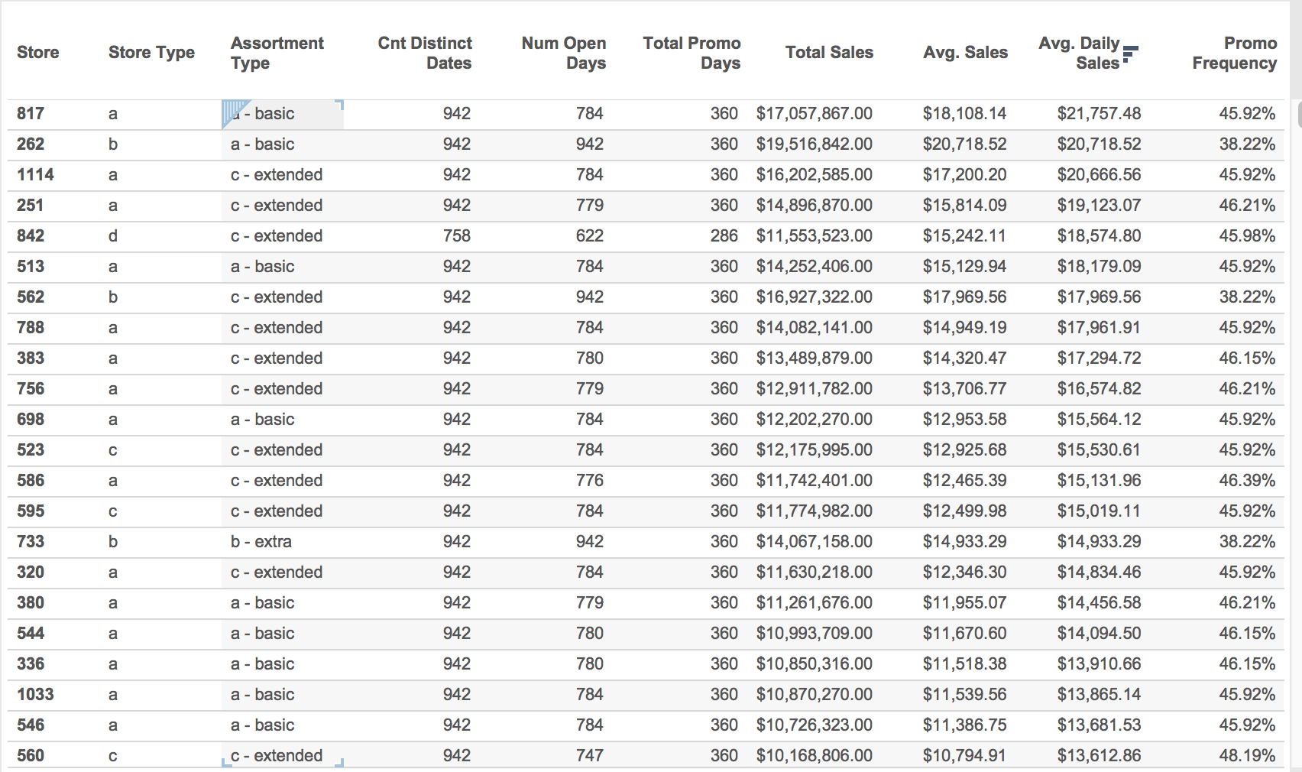

1. Create a new worksheet and create the following graph:
   1. Use a “Percent Difference” table calculation.
   2. Name this worksheet “%Diff in MonthlySales”

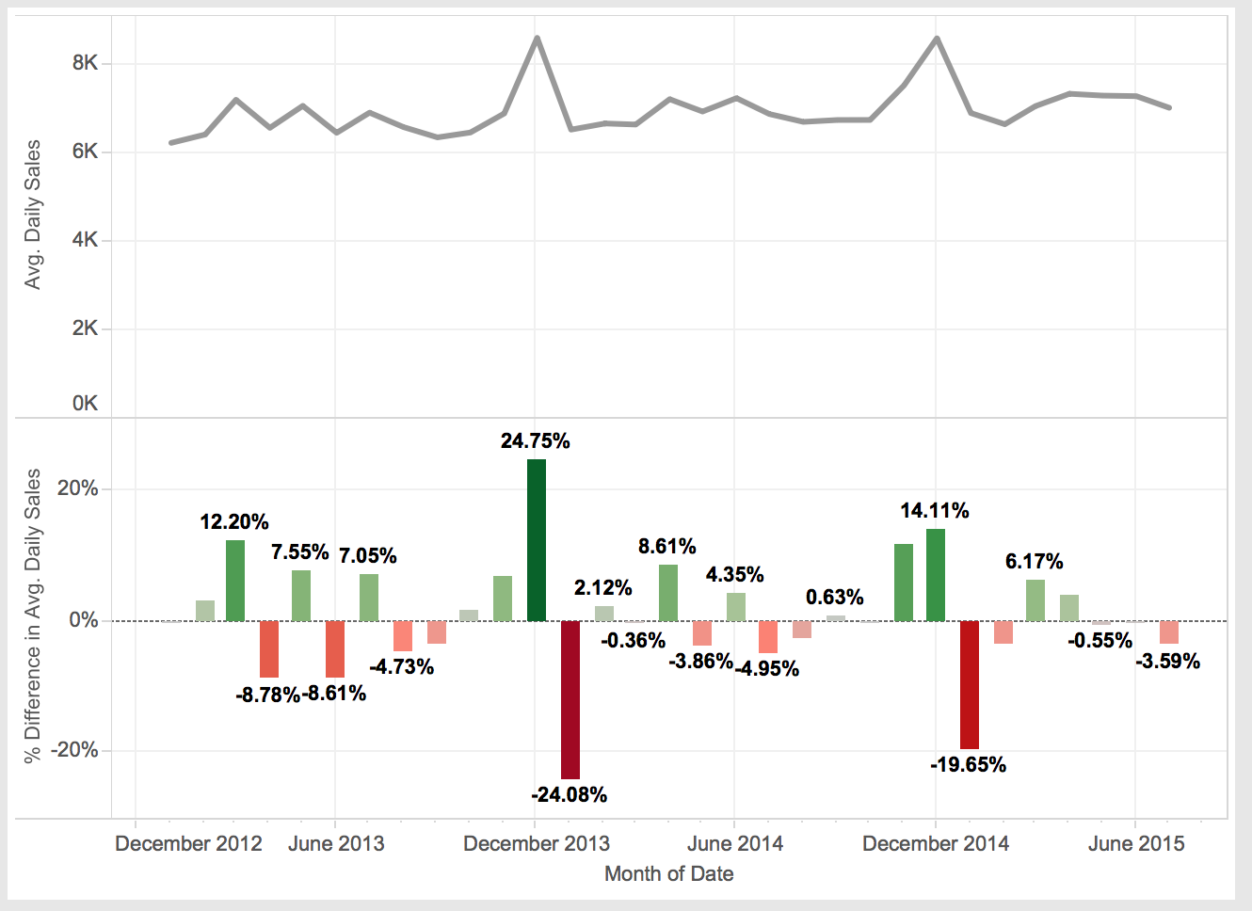

1. Create a new worksheet and create the following bar chart:
   1. Arrange the stores by descending Avg. Sales
   2. Color-code the stores by Store Type
   3. Use the Number of Open Days as the “Size”. Edit the sizes and select “Sizes vary… by range” to highlight the differences in number of open days.
   4. Add the “Open” flag to the filter shelf. Click the filter and select “Show filter”.
   5. How does the list change when “All” dates are included vs. just the open dates (i.e. Open = 1)? Why?
   6. Click on “Store” in the Row shelf and select Filter. Use the “Top” tab to filter the stores to the Top 10 stores by Avg. Sales.
   7. Rename this worksheet to “Top 10 stores by Avg. Sales”

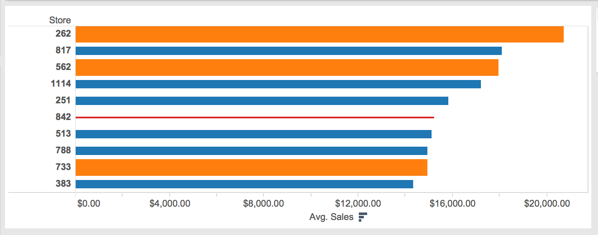

1. Create the following histogram:
   1. Convert the “Competition Open Since Month” and “Competition Open Since Year” to a date. (HINT: Use the DATE() function, be sure to account for zeros).
   2. Use DATEDIFF() to create the calculated field “Months since competition open”.
   3. Highlight the calculated field and click the histogram icon in the “Show Me” box.
   4. Set dynamic bin size:
      1. Click on “Months since competition open (bin)” field in the Dimensions shelf and click edit.
      2. Click on “Size of bins” and select “*Create new parameter…”.* Give the parameter a meaningful name, such as “Months (bin)”
      3. Click on the newly created parameter and select “Show parameter control”
      4. Play with different parameters and note how the histogram changes.
   5. Think about whether this is a valuable histogram. Why or Why not?
   6. Rename this worksheet “Hist. of M since CustOpen”

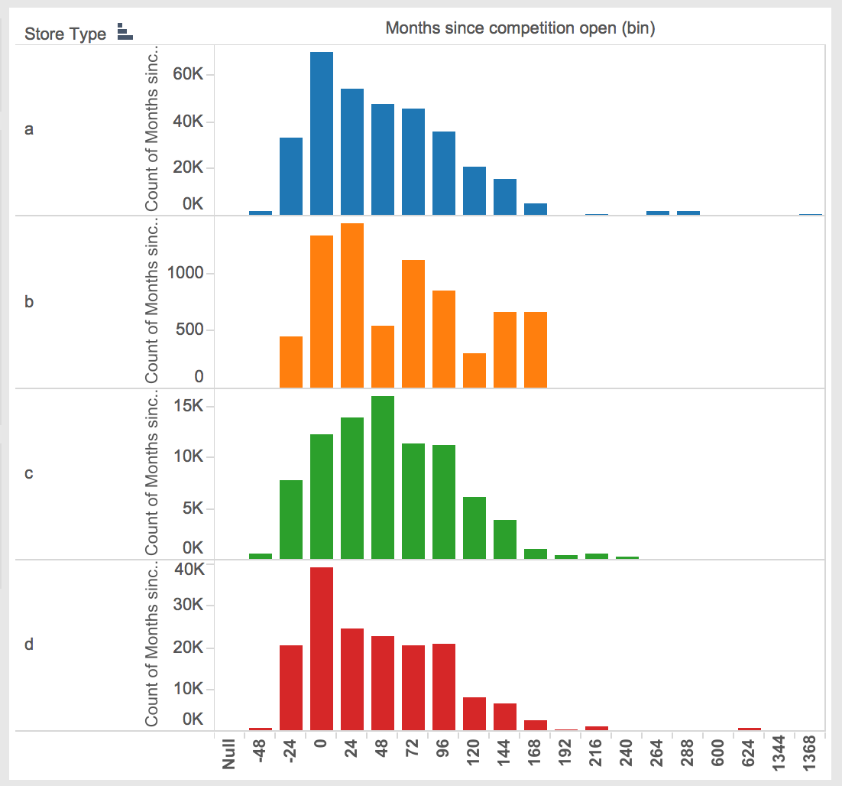

1. Create a new worksheet and create a plot of the Avg. Daily Sales vs. Avg. Daily Customers color-coded by Store Type with Trend Lines.
   1. Rename this worksheet “Avg. Daily Sales vs. Avg. Daily Customers”

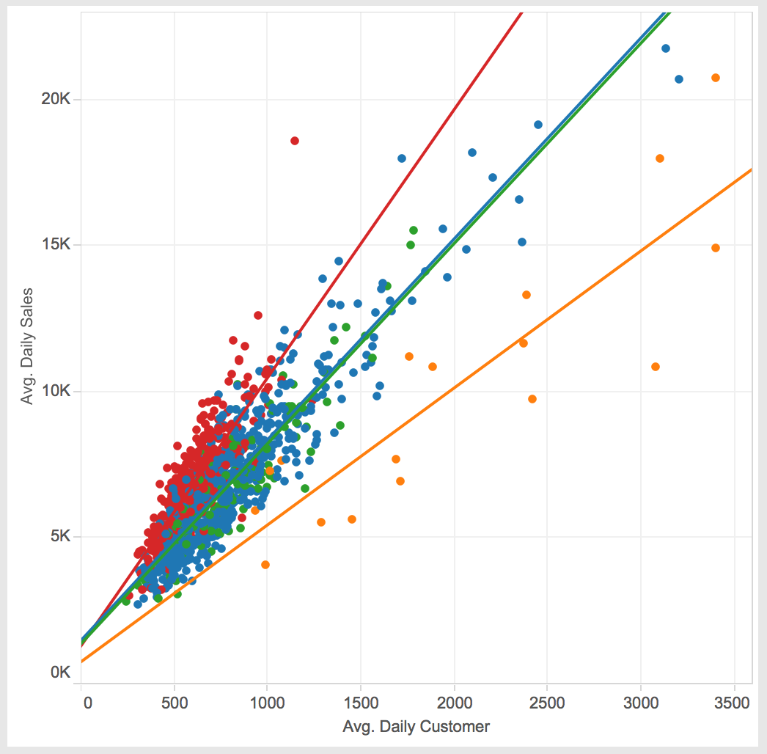

1. Create a new worksheet and create a plot of Avg. Daily Sales by Qtr. color-coded by Store Type and shown for each “Assortment Type”.
   1. Add the forecast for the next 5 Qtrs.
   2. Rename this worksheet “Forecast Qtrly Sales”

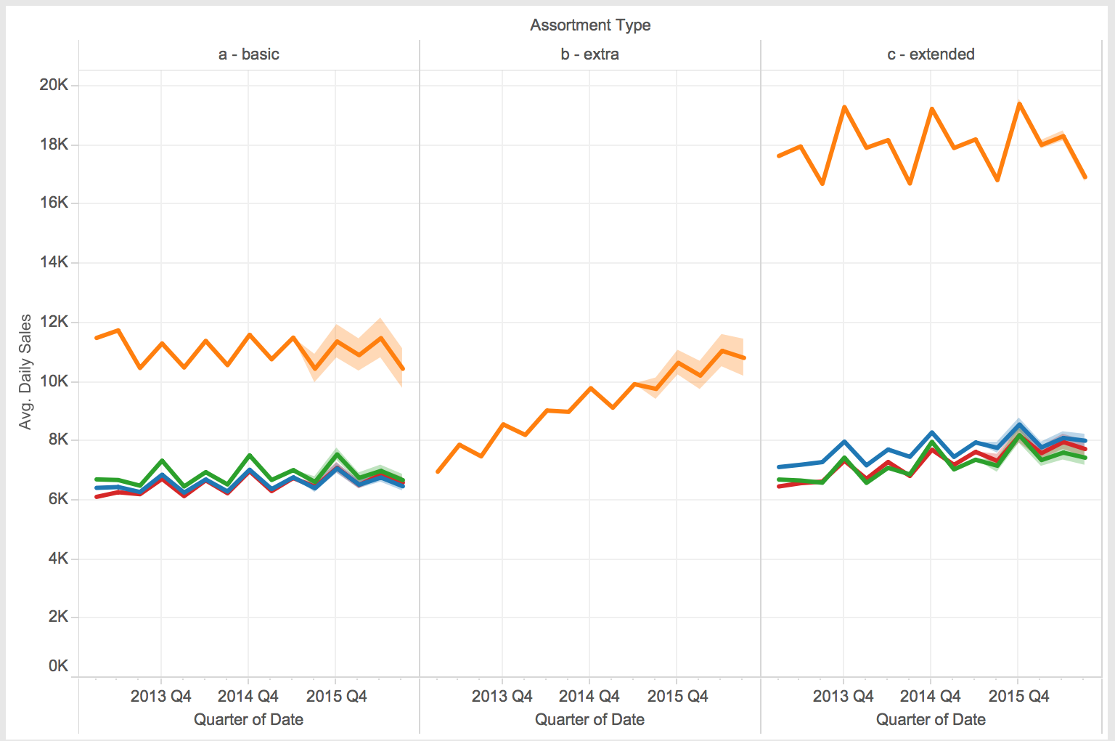

**Part II - Dashboard**

1. Create the following dashboard. Make dashboard interactive by highlighting sections when Store Type is selected

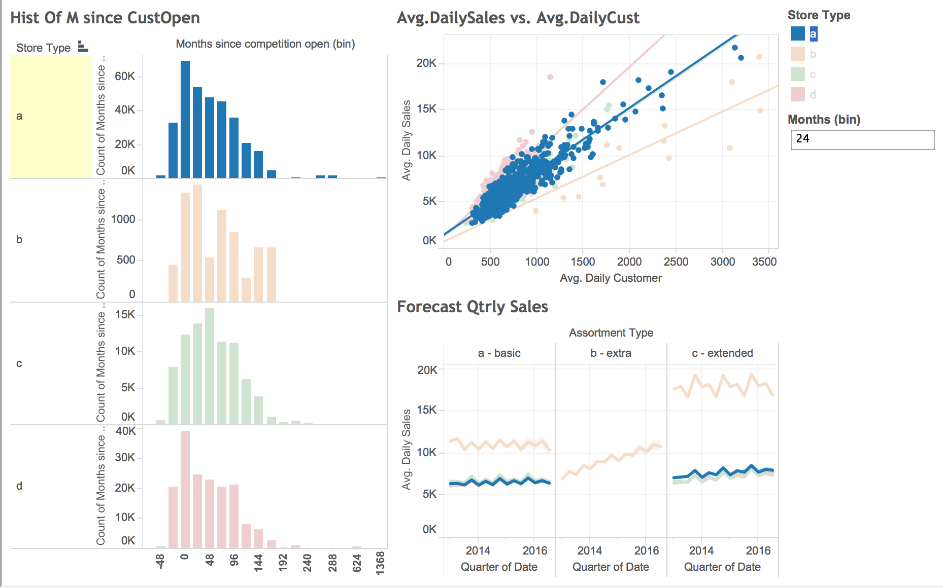

1. Create a new dashboard. Make dashboard interactive by showing only the Cross Tab and %Diff of Monthly sales for the Store that is selected in the Top 10 list.

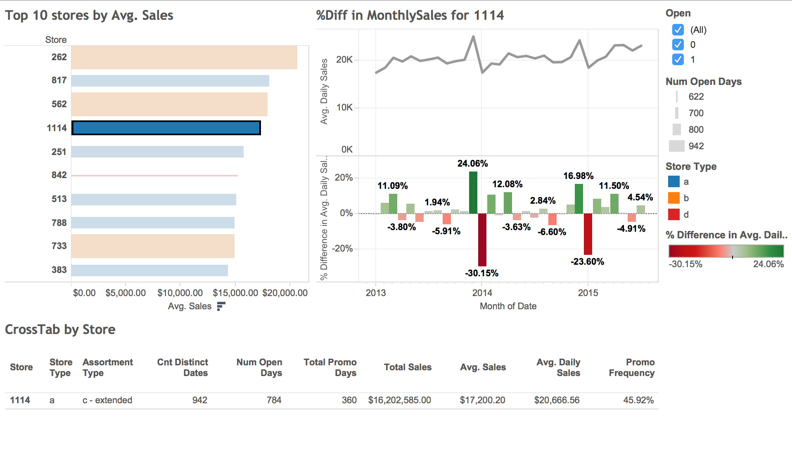

**Part III: Burning Glass xCase**

Create remaining visualizations